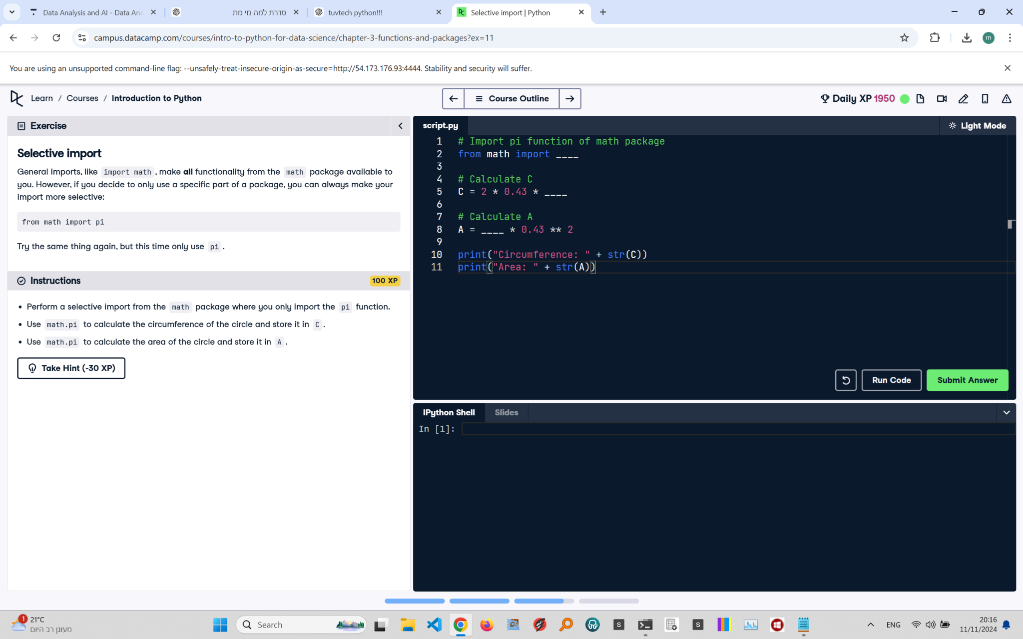

Question: Perform a selective import from the math package where you only import the pi function. Use math.pi to calculate the circumference of the circle and store it in C. Use math.pi to calculate the area of the circle and store it in A.

Answer:

# Import only the pi function from math  
from math import pi  
  
# Calculate C  
C = 2 * 0.43 * pi  
  
# Calculate A  
A = pi * 0.43 ** 2  
  
# Print the results  
print("Circumference: " + str(C))  
print("Area: " + str(A))

Explanation: This code performs a selective import of only the pi constant from the math package. The circumference (C) is calculated using the formula 2 * radius * pi, and the area (A) is calculated using pi * radius squared. This approach is efficient as it imports only what is needed.